Lab 6 Prelab – Operating Systems

Suraj Mandal

N01537188

Part A:

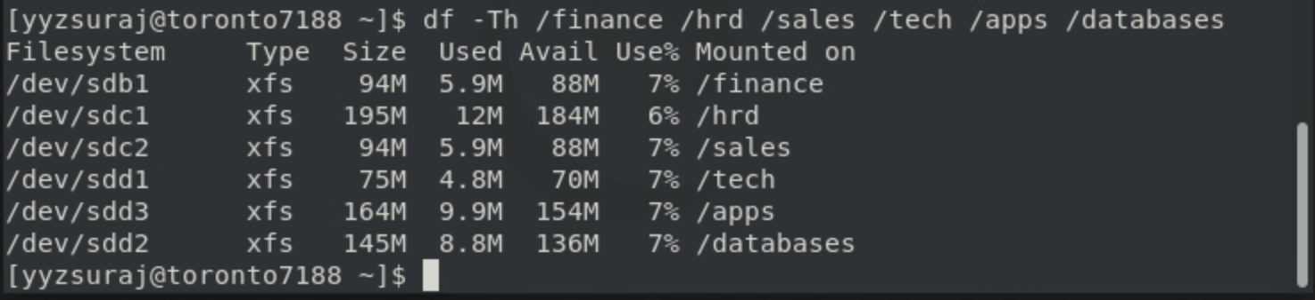

Part B:

A.

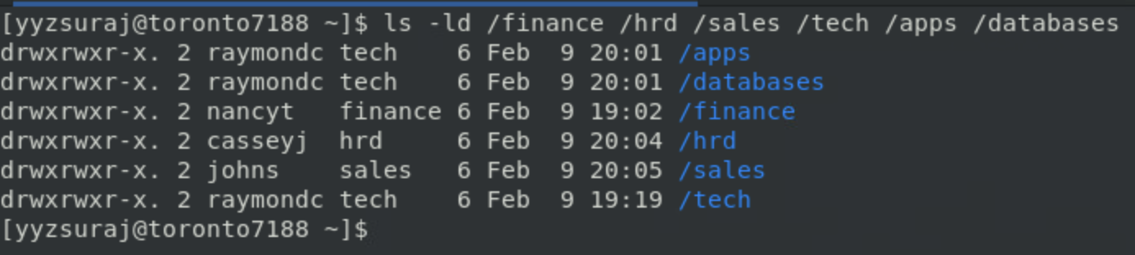

Next Page

B.

Part C:

A.

B.

C.

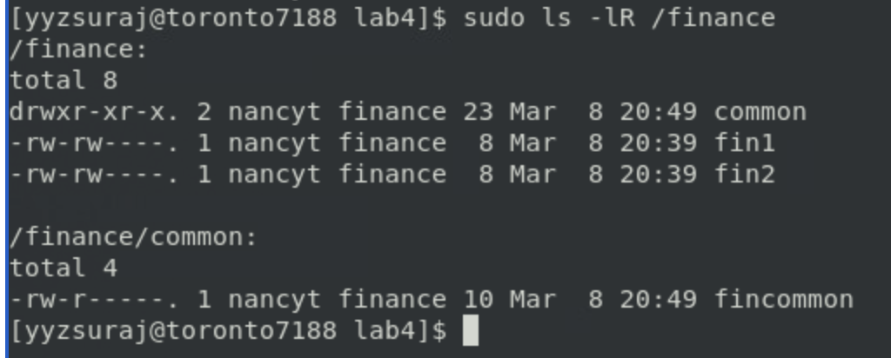

Part E:

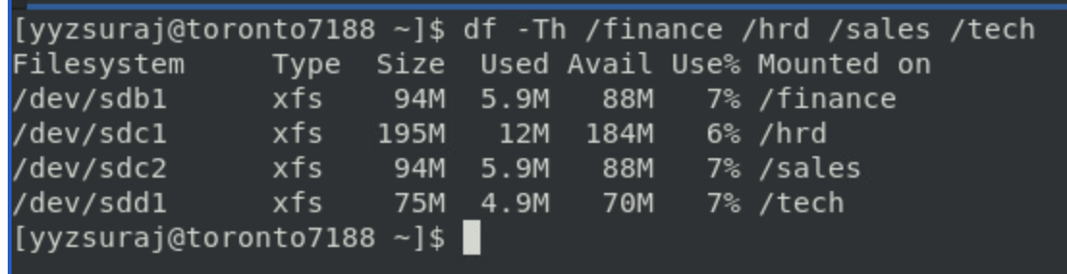

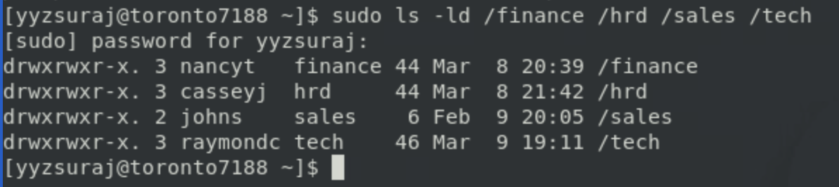

Part F:

24.

25.

26.

NEXT PAGE

27.

NEXT PAGE

28.

NEXT PAGE

Part G:

30.

a)

b)

